ALTA 3.3 ZONING—COMPLETED IMPROVEMENT—NON-CONFORMING USE ENDORSEMENT

This endorsement is issued as part of Policy Number

issued by CATIC

1. For purposes of this endorsement:

a. “Improvement”: A building located on the Land at the Date of Policy.

b. “Non-Conforming Use”: The use of the Land described in Section 2.a. existing at the Date of Policy and before the Zoning Ordinance was enacted, although the use is not authorized in the Zoning Ordinance.

c. “Zoning Ordinance”: A zoning ordinance or zoning regulation of a political subdivision of the State that is in effect and applicable to the Land at the Date of Policy.

2. The Company insures against loss or damage sustained by the Insured resulting from:

a. The following Non-Conforming Use not being allowed by the governing political subdivision of the State because the Non-Conforming Use violates the Zoning Ordinance: [*Drafting Instruction: Describe the existing Non-Conforming Use*]

b. A final decree of a State or federal court having jurisdiction either prohibiting the Non-Conforming Use or requiring the removal or alteration of the Improvement because, at the Date of Policy, the Non‑Conforming Use violates the Zoning Ordinance with respect to any of the following matters:

i. The area, width, or depth of the Land as a building site for the Improvement;

ii. The floor space area of the Improvement;

iii. A setback of the Improvement from the property lines of the Land;

iv. The height of the Improvement; or

v. The number of parking spaces.

3. Section 2 does not insure against loss or damage and the Company will not pay costs, attorneys’ fees, or expenses resulting from:

a. The lack of compliance with any condition, restriction, or requirement contained in the Zoning Ordinance regarding the continuation or maintenance of the Non-Conforming Use;

b. The failure to secure necessary consents or authorizations as a condition for continuing the Non‑Conforming Use;

c. The invalidity of the Zoning Ordinance, the effect of which is to prohibit the Non-Conforming Use;

d. Any change, cessation, abandonment, or replacement of the Non-Conforming Use or an Improvement;

e. A prohibition to restore an Improvement;

f. The violation of or the lack of compliance with any law, order, or regulation regarding the continuation or maintenance of the Non-Conforming Use or an Improvement;

g. Any law, order, or regulation requiring the amortization, expiration, or elimination by passage of time of the Non-Conforming Use; or

h. Any refusal to purchase, lease, or lend money on the Title.

This endorsement is issued as part of the policy. Except as this endorsement expressly states, it does not (i) modify any of the terms and provisions of the policy, (ii) modify any prior endorsement, (iii) extend the Date of Policy, (iv) insure against loss or damage exceeding the Amount of Insurance, or (v) increase the Amount of Insurance. To the extent a provision of the policy or any prior endorsement is inconsistent with an express provision of this endorsement, this endorsement controls. Otherwise, this endorsement is subject to all of the terms and provisions of the policy and any prior endorsement.

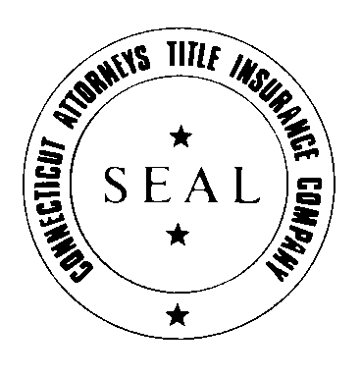CATIC



JAMES M. CZAPIGA, PRESIDENT