INSTRUCTIONS FOR ALTA ENDORSEMENT FORM 5.1-06
PLANNED UNIT DEVELOPMENT

PURPOSE OF ENDORSEMENT

The ALTA 5.1-06 Planned Unit Development Endorsement insures against loss or damage resulting from: (1) present violations of any restrictive covenants referred to in the policy's Schedule B that restrict the use of the land or the forfeiture or reversion of Title by reason of those covenants; (2) any charges or assessments in favor of a homeowners' association that are due and unpaid at Date of Policy; (3) the enforced removal of any existing structure other than a boundary wall or fence because it encroaches onto adjoining land or into any easement; and (4) failure of the Title by reason of an existing right of first refusal.

This endorsement can be used when the property to be insured is part of a planned unit development. The insured property in a planned unit development can consist of a fee simple interest in a lot, townhouse, or other single-family residence together with an appurtenant easement in common elements. The endorsement may be used with either a Loan Policy or an Owner's Policy.

UNDERWRITING REQUIREMENTS

• Obtain a fully executed Owner's Affidavit (CATIC A-100) as well as any documentation required by state statute to be provided to the buyer, where applicable.

The Owner's Affidavit, together with any other available information, must confirm that:

1. common charges or assessments are current;
2. there are no violations of existing covenants; and
3. there are no encroachments of improvements over a boundary line or into any easements.

• Any restrictive covenants need to be reviewed to confirm that there is no forfeiture or right of reversion provision.

• Any right of first refusal must be waived by the homeowners' association prior to closing.

This endorsement may be incorporated into the policy by checking the appropriate box at the bottom of the policy’s Schedule B.

Please contact a member of CATIC's underwriting staff if there are questions about the issuance of this endorsement.

PLANNED UNIT DEVELOPMENT ENDORSEMENT

Attached to and made a part of Policy No.

The Company insures against loss or damage sustained by the Insured by reason of:

- Present violations of any restrictive covenants referred to in Schedule B that restrict the use of the Land or the forfeiture or reversion of Title by reason of any provision contained in the restrictive covenants. As used in this paragraph 1, the words "restrictive covenants" do not refer to or include any covenant, condition, or restriction (a) relating to obligations of any type to perform maintenance, repair, or remediation on the Land, or (b) pertaining to environmental protection of any kind or nature, including hazardous or toxic matters, conditions, or substances, except to the extent that a notice of a violation or alleged violation affecting the Land has been recorded in the Public Records at Date of Policy and is not excepted in Schedule B.

- Any charges or assessments in favor of any association of homeowners, that are provided for in any document referred to in Schedule B, due and unpaid at Date of Policy.

- The enforced removal of any existing structure on the Land (other than a boundary wall or fence) because it encroaches onto adjoining land or onto any easements.

- The failure of the Title by reason of a right of first refusal to purchase the Land that was exercised or could have been exercised at Date of Policy.

This endorsement is issued as part of the policy. Except as it expressly states, it does not (i) modify any of the terms and provisions of the policy, (ii) modify any prior endorsements, (iii) extend the Date of Policy, or (iv) increase the Amount of Insurance. To the extent a provision of the policy or a previous endorsement is inconsistent with an express provision of this endorsement, this endorsement controls. Otherwise, this endorsement is subject to all of the terms and provisions of the policy and of any prior endorsements.

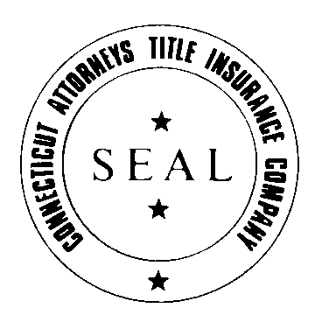 | CATIC  By  JAMES M. CZAPIGA, PRESIDENT

